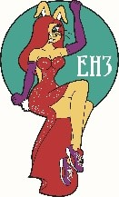 | 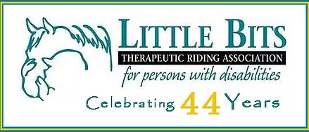 | 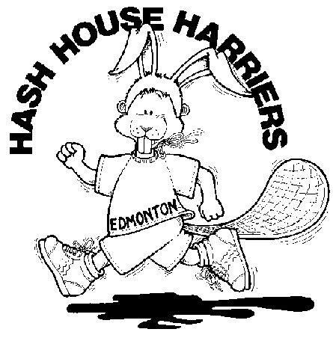

Edmonton Hash House Harriers
26th Annual Red Dress Run
Cash Donation Form

Thank you for your donation! Funds raised from the Edmonton Hash House Harriers’ 26th Annual Red Dress Run will support Little Bits Therapeutic Riding Association. They are a non-profit, charitable organization providing recreational horseback riding with therapeutic benefits for children and adults with disabilities in Edmonton Alberta. Each year, more than 115 riders benefit from their spring and fall program and 50 riders in their winter program. They have programs for pre-school aged children (Itty Bits), children aged five and a half to 18 (Little Bits) and adults (Big Bits). Once a week, riders receive riding instruction by certified and experienced instructors assisted by a core of volunteers. The focus is on skill development, enjoyment and the unique therapeutic aspects of horseback riding.

The Red Dress Run will be raising funds to purchase horses that are appropriately skilled and suited for therapeutic riding programs.

Amount of Contribution: _____________________________________________

Payment Method (please circle): Cheque Cash

Please make cheques payable to “Little Bits Therapeutic Riding Association”

Mailing address for tax receipt:
Name
Address
City, Province, Postal Code

