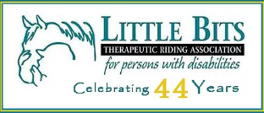
Edmonton Hash House Harriers
26th Annual RED DRESS RUN (2019)
Donor Information Form

Hash Name:

Tax Receipt Requested Yes No

If you would like a tax receipt, please provide the following information:

Proper Name:

Address:

Postal Code: Phone Number:

(For EH3 Donation Collector Use only) | Description of Donated Item | Proof of Value is Attached to this Form-  Yes or No | Market Value | (For Charity Use Only)

You MUST complete this form to obtain a tax receipt for your donation – minimum $20

If documentation of market value (i.e. receipt, store flyer, internet site) does not accompany the individual donations, the charity will not issue a tax receipt.

Donations of services and other intangible items are not eligible for tax receipts. Gift certificates require proof of purchase.

Donations of artwork and other handcrafted items require a proof of value certificate (such as an appraisal)

Donations of dinners & special events require receipts for goods provided AFTER the event has been completed. The charity will issue a tax receipt after you’ve hosted the event & they have received the proof of purchase for these items.

Refer to Canada Revenue Agency for more information
http://www.cra-arc.gc.ca/chrts-gvng/dnrs/rcpts/dntn2-eng.html

